Early stoping at epoc = 10

[0.06500385531920094, 0.98043309621719]

[0.11103756540611051, 0.9681565485664763]

Early stoping at epoc = 6

Number of units = 80

[0.055431707755061226, 0.9819449822198173]

[0.09618156418216736, 0.9710779728941166]

Early stoping at epo = 10

Numbe rof units = 60

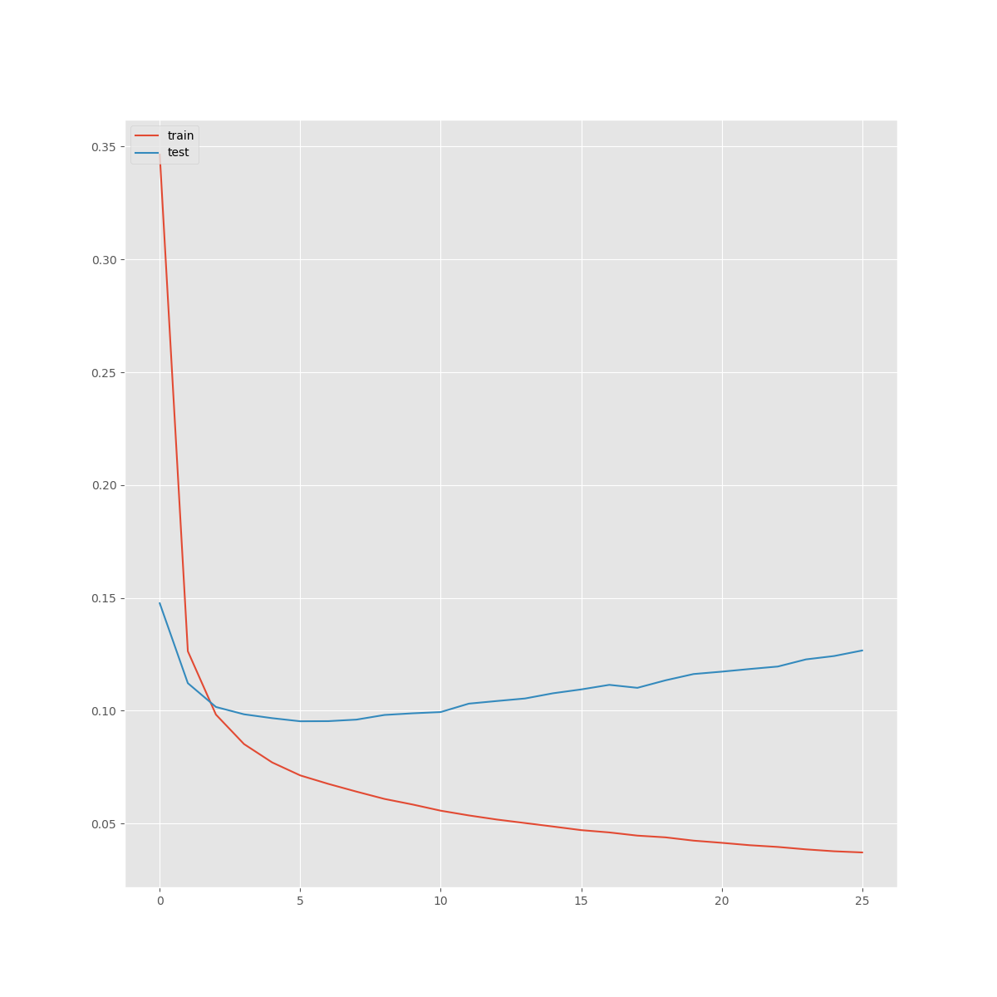

[0.04494889740843845, 0.9852849769888361]

[0.09886700810990401, 0.9711981041914627]

Combined

[0.06548670074968842, 0.9795265884715847]

[0.10820386560013932, 0.9685553629463965]

[0.08486611803578291, 0.9726082063632272]

[0.12723815888539267, 0.9619047431472543]

[0.7686752495101749, 0.8455858534781756]

[0.7790687597722585, 0.8434261737315231]

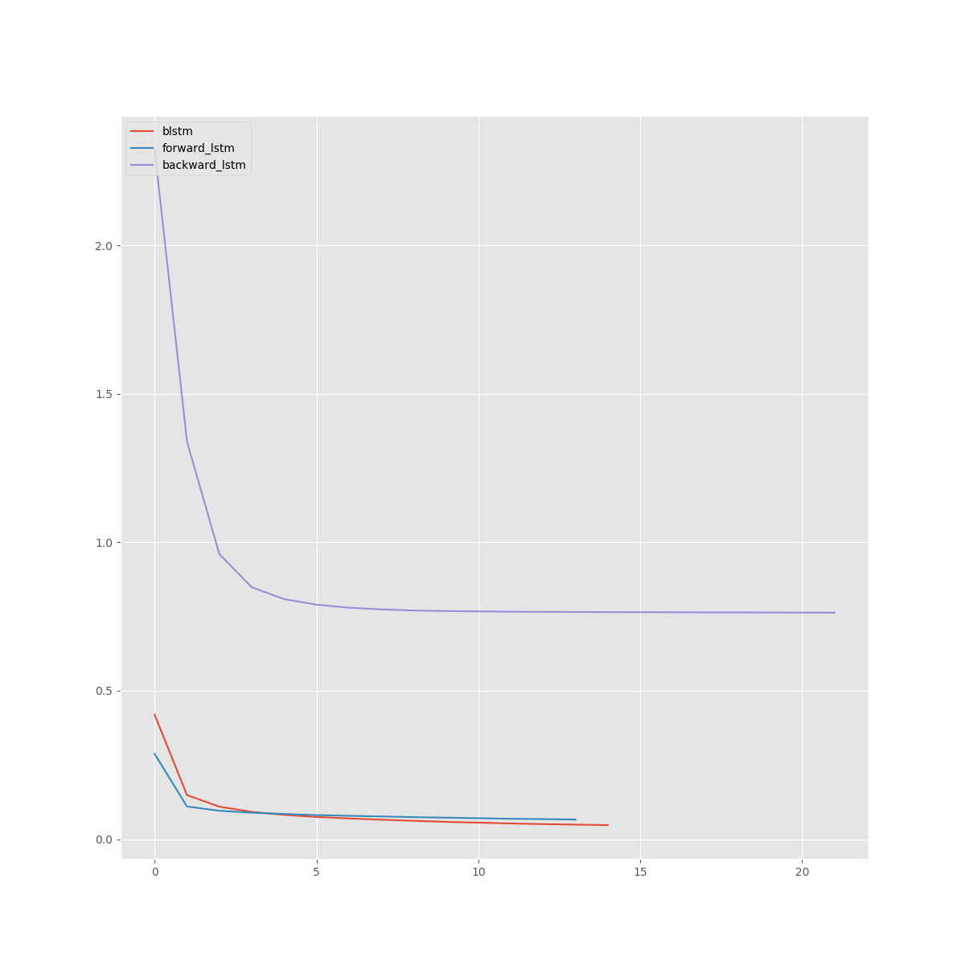

1056/1063 [============================>.] - ETA: 0s - loss: 0.0543 - acc: 0.9849Epoch 00038: val_acc improved from 0.95874 to 0.95923, saving model to best_mo

[0.07105669425204789, 0.9827606525521605]

[0.17692783792634625, 0.9560446223697147]

Dropout = 0.3

1056/1063 [============================>.] - ETA: 0s - loss: 0.0343 - acc: 0.9904Epoch 00054: val_acc improved from 0.95921 to 0.96013, saving model to best_model.h5

[0.055950261820654296, 0.987337425250232]

[0.17841346141275344, 0.9574448681092477]

0.4

1056/1063 [============================>.] - ETA: 0s - loss: 0.0365 - acc: 0.9897Epoch 00050: val_acc improved from 0.95889 to 0.95938, saving model to best_model.h5

[0.057278377460168665, 0.9865029954300328]

[0.1794988161271757, 0.9585528407726918]

0.5

1056/1063 [============================>.] - ETA: 0s - loss: 0.0651 - acc: 0.9821Epoch 00034: val_acc improved from 0.95898 to 0.95929, saving model to best_model.h5

[0.07375661868453474, 0.9818965403813003]

[0.17472202637353101, 0.9523952572911352]

0.6

[0.06342494238849149, 0.9847943045484832]

[0.18433330380343818, 0.954261632831963]

Comparison

[0.05262161788217456, 0.9840120181844461]

[0.11518305786159061, 0.9674222103449779]

[0.07448630270485099, 0.9761584684783287]

[0.13329902190631185, 0.9612488830656285]

[0.7752992953224065, 0.8455373995347484]

[0.7850883229759159, 0.8434119477582236]

Merge mode comparison

concat

[0.06146941377176567, 0.984701034581419]

[0.17901727100750348, 0.9557363514427666]

sum

[0.0618663166220068, 0.9852034529408985]

[0.16441153379173967, 0.9569896477478761]

mul

[0.05322583094295297, 0.9875175194510667]

[0.1660113951286396, 0.9582442822041096]

ave

[0.04525112170106581, 0.9897508720781141]

[0.1608428111126473, 0.9584332987352893]

Merge mode comparison full dataset

concat

[0.06374960818355588, 0.9800211604522825]

[0.10808899793603005, 0.9682347939549335]